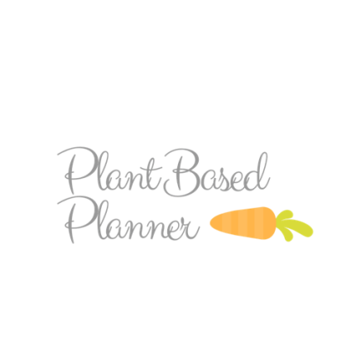
Desserts
_______________________________

The beauty of plant-based desserts is that they can be pretty healthy if you want them to be, or you can indulge in the real sugar-laden sweets too, if you’d like! Here is a good sample of healthy and indulgent with an ingredient list including everything you’ll need to make these plant-based treats!

Black bean brownies:
http://chocolatecoveredkatie.com/2012/09/06/no-flour-black-bean-brownies/
- 1 15oz can Black Beans
- Cocoa Powder
- Quick Cooking Oats
- Maple Syrup or Agave
- Sugar (use Coconut sugar is you’d like unrefined. Whole Foods carries coconut sugar)
- Coconut OR Vegetable Oil
- Pure Vanilla Extract
- Baking Powder
- Vegan Chocolate Chips (Trader Joes semi-sweet choclate chips are Vegan!)
- Salt

8 Vegan Banana Soft Serve “Nice Cream” Recipes: https://wholefully.com/8-vegan-banana-soft-serve-recipes-to-keep-you-cool/
- Bananas (2 frozen per serving)
  - For Apple Cinnamon:
    - Apple Butter
    - Pure Vanilla Extract
    - Cinnamon
  - For Chocolate:
    - Unsweetened Cocoa Powder
    - Pure Vanilla Extract
  - For Pumpkin Spice
    - Apple Butter
    - Pumpkin Puree
    - Pumpkin Pie Spice
  - For Strawberry
    - Frozen Strawberries
    - Vanilla Extract
  - Peanut Butter
    - Natural Peanut Butter
    - Salt
    - *P.B.P. Tip: Add a couple of dates for added flavor and sweetness!
  - Carrot Cake
    - Apple Butter
    - 1 Large Carrot
    - Pure Vanilla Extract
    - Raisins
    - Chopped Walnuts
  - Pina Colada
    - Canned Pineapple
    - Full fat coconut milk (from a can)
    - Unsweetened coconut flakes

Flourless Breakfast (Thumbprint) Cookies:
http://ohsheglows.com/2014/10/24/flourless-thumbprint-breakfast-cookies-vegan-gf/
- Rolled Oats
- Ripe Banana
- Chia Seeds or Flax Seeds
- Sea Salt
- Cinnamon
- Jam
- Peanut butter (alt. Nut butter) *optional for topping/drizzling

5 Ingredient Salted Caramel Peanut Butter Truffles: https://minimalistbaker.com/5-ingredient-salted-caramel-peanut-butter-truffles/#_a5y_p=2175672
- Medjool Dates (Trader Joes, Whole Foods, Harris Teeter)
- Natural Peanut Butter
- Dairy-free chocolate/Dark Chocolate
- Sea Salt
- Coconut Oil (*P.B.B. note: I omit the coconut oil when I make these).

Super Healthy Peanut Butter Date Special-K Bars: https://www.halfbakedharvest.com/super-healthy-peanut-butter-date-special-k-bars/
- Medjool Dates (Trader Joe’s, Whole Foods, Harris Teeter)
- Creamy Peanut Butter
- Non-dairy milk
- Pure Vanilla Extract
- Corn Flakes
- Dark Chocolate
- Sea Salt

The Ultimate Chewy Chocolate Chips: http://veganchowdown.com/ultimate-chewy-chocolate-chip-cookies/
- Vegan Butter (I use Earth Balance!)
- Brown Sugar
- Sugar
- Non-dairy milk
- Pure Vanilla Extract
- Flour
- Bakin Soda
- Chocolate Chips
- Salt

Dark Chocolate Peanut Butter Banana Bites: http://smilesandwich.com/2014/04/02/dark-chocolate-peanut-butter-banana-bites/
- Bananas
- Creamy Peanut Butter
- Dark Chocolate
- Coconut Oil

